TSTool Point Flow Analysis Quick Start Guide

2014-04-15

# Introduction

This document provides an overview of how to perform a “point flow” analysis using the TSTool software, as well as indicating potential interaction with other point flow analysis tools. After reading this document you should understand point flow analysis concepts and have enough understanding to begin implementing an analysis.

# Point Flow Analysis Background

The intent of a point flow analysis is to calculate flow and other values within a stream system using simple mass balance calculations. A point flow analysis approach is somewhere in the middle of the modeling spectrum in terms of complexity:

* Summary mass balance – add all inputs and outputs in gross terms
* Point flow analysis – represent important points, time steps are solved independently
* System model – conceptualize system, one time step may impact others

For each analysis approach, it is necessary to represent the physical system in a conceptual way that corresponds to available data. A typical point flow analysis represents the system as a series of nodes, each of which has a single downstream node (the exception being the end node, which has no downstream node). This representation and mass balance calculations are shown in the following figure.



The solid circles represent known point flow locations, typically stream gages where flow is measured to a reasonable accuracy. The hollow circles represent intervening points where water is subtracted (e.g., at a diversion to agriculture), added (e.g., at an inflow point such as a municipal wastewater treatment plant), or left unchanged (e.g., an instream flow reach for environmental flows). Simple mass balance calculations can be performed for each stream reach (defined as the stream between gages) starting with the upstream known flows at the gage(s), and then move downstream to subtract diversions and add inflows. The resulting accumulated error when compared with the downstream known flow (gage) is the error over the entire stream reach. If the error is positive, it means that the stream is gaining. If the error is negative, it means that the stream is losing. Gains and losses are due to groundwater interactions and other additions and subtractions that are not explicitly accounted for in the analysis. In order to make the numbers balance in the reach the error at the downstream point must be distributed back to other nodes in the reach.

Fundamental data inputs required for a point flow analysis include:

1. System representation (the network)
2. Time series associated with nodes
3. Calculation rules for nodes

System Representation

Two representations of the network are discussed in the following sections, one from Excel, and one from the StateMod model used in Colorado’s Decision Support Systems. In each case, the following basic data is needed for each node in the network:

* Node identifier (ID), for example stream gage ID
* Node name, for example stream gage name, useful for visualization
* Node type, for example whether a stream gage, diversion, inflow
* Downstream node, to provide network connectivity

Additional optional node data include:

* Stream mile, needed to prorate gains and losses by distance
* Gain/loss weight, if distributing the gains and losses by weighting node values
* Information used to identify the time series data

Time Series

Time series of the appropriate data type must be associated with the nodes in order to perform the mass balance calculations. TSTool provides commands to read time series given a list of node identifiers and other information, as illustrated further in the following sections.

Calculation Rules

The calculation

# Spreadsheet Network Representation

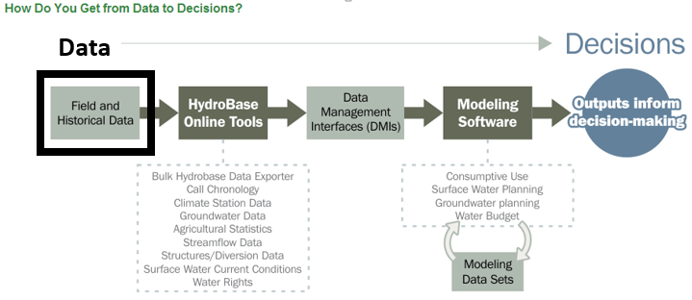

CDSS “Field and Historical Data” include data needed to perform State business related to water. Such data include water rights, diversion and streamflow records, river calls, and other data, and are managed in the State’s HydroBase and other databases. HydroBase is a SQL Server database that is available from the DWR for a fee and is also available on-line (see HydroBase Online Tools section below). These data are used by modelers to create model data sets, which are discussed in the Modeling Software section below.

Foundational data often relate to some type of regulated process. For example, water rights are issued consistent with the prior appropriation doctrine and associated laws, regulations, and procedures. Such data are typically available on the web and may include scans of original documents. See the HydroBase Online Tools section below for more information.

Data observations such as streamflow, diversions, and well pumping may be collected by automated systems, provided by users (“user-supplied” data) or may be collected by State of Colorado personnel (e.g., estimates by water commissioners). Many large diversion headgates have automated measuring devices, and the data flow into State databases to help DWR staff with water administration and water management decisions such as compliance with interstate compacts. Increasingly, such data is available on the web, with real-time data having a disclaimer about the data being provisional.

Some field data is available only as scanned documents. In some cases, original documents in Microsoft Word, Excel, or other formats are available. However, some electronic documents were scanned to images but the electronic originals are not available online. Availability varies by the year that documents were scanned, policies in place at the time, and the source of data. Documents can be accessed throughout the CDSS, CWCB, and DWR website, indicated by “Laserfiche”, “WebLink”, “Imaged Documents”, or similar links. Additional guidance for using online documents is provided in this and other Quick Start documents.

# StateMod Model Network Representation

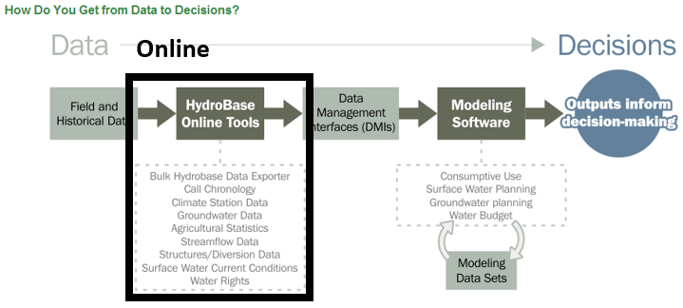

HydroBase online tools are accessible from the DWR and CWCB web pages:

* DWR: http://water.state.co.us/DATAMAPS/Pages/default.aspx
* CWCB: See the Online Tools links on the main CDSS web page: http://cdss.state.co.us

Online tools provide access to data via a web browser using interactive forms. These tools are useful for ad hoc data queries such as data for a single structure or a bulk query for a water district or division. For example, the Water Rights

# TSTool Time Series Processing

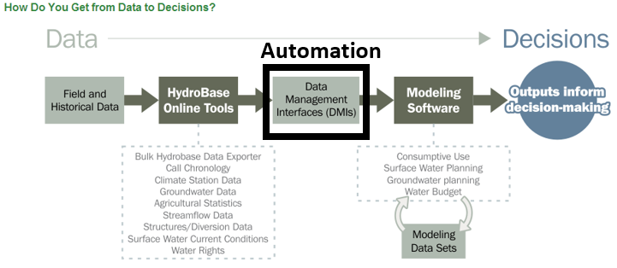

xx

# TSTool Point Flow Analysis

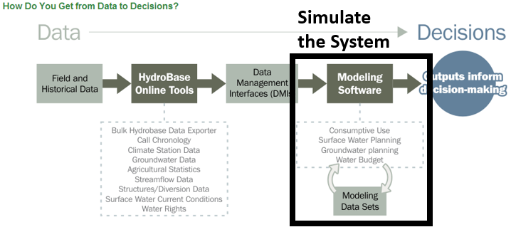

xxx

# Visualizing Point Flow Analysis Results

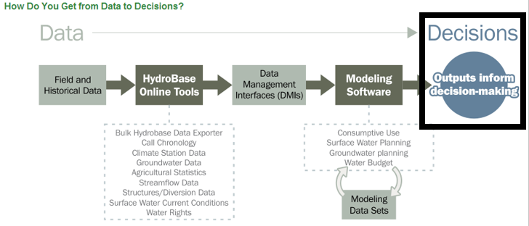

xxx

# Point Flow Analysis Potential Issues

After reading this CDSS Quick Start guide you should have a high-level understanding of what is provided by CDSS and where to find more information

# Next Steps

After reading this CDSS Quick Start guide you should have a high-level understanding of what is provided by CDSS and where to find more information. Additional Quick Start documents have been prepared or are envisioned to provide more specific introductory information. See the Open Water Foundation website ([www.openwaterfoundation.org](http://www.openwaterfoundation.org)) information for users.

* TSTool Quick Start
* Point Flow Analysis Quick Start (envisioned)
* StateDMI Quick Start (envisioned)
* StateMod Quick Start (envisioned)
* StateCU Quick Start (envisioned)

# Resources

* CDSS website: cdss.state.co.us
* CWCB website: cwcb.state.co.us
* DWR website: water.state.co.us